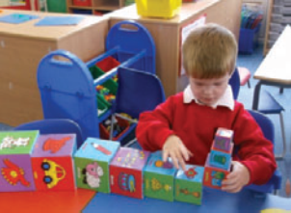

**LUNCHTIME ASSISTANT**

**5 hours per week (1 hour per day) term time only (12.20 – 1.20 pm, Mon to Fri)**

**£24,027 (pro-rata) – actual salary £2,714 per annum**

We have a vacancy for a Lunchtime Assistant to join our established team and to help further enhance the enjoyment of lunchtimes for our children, through adult led activities and games.

Our school benefits from three playground areas and an extensive playing field.

Micklands has a friendly and caring ethos where you will quickly feel part of the team.

**Application packs are available on our school website** [**www.micklands.reading.sch.uk**](http://www.micklands.reading.sch.uk)

**All applications should be emailed to** [**brapson@micklands.reading.sch.uk**](mailto:brapson@micklands.reading.sch.uk)

**Please do not send a CV, as for the purpose of Equal Opportunities, we can only accept Reading Borough Council application forms.**

**Closing date for applications: Friday 6th December 2024**

**Interviews will take place on: Friday 13th December 2024**

*The school is committed to safeguarding and promoting the welfare of children and young people, and expects all staff to share that commitment. Successful candidates will be subject to an enhanced DBS check & staff childcare disclosure declaration.*

Micklands Primary School

Micklands Road, Caversham, Reading, Berkshire RG4 6LU

T 0118 9375500 E office@micklands.reading.sch.uk

Headteacher: Mr Mark Frost

www.micklands.reading.sch.uk